Natural Language Processing to Graph Queries
Configuration Management Plan



Revision Sheet 5
1. INTRODUCTION 6
1.1 Purpose 1 6
1.2 Scope 6
1.3 Definitions and Acronyms 6
1.3.1 Key acronyms 6
1.3.2 Key terms 6
1.4 References 6
2. Software Configuration Management (SCM) 6
2.1 SCM Organization 6
2.2 SCM Responsibilities 6
2.3 Relationship of CM to the software process life cycle 6
2.4 SCM Resources 6
3. SCM ACTIVITIES 6
3.1 Configuration Identification 6
3.1.1 Specification Identification 6
3.1.2 Change Control Form Identification 6
3.1.3 Project Baselines 6
3.1.4 Library 7
3.2 Configuration Control 7
3.2.1 Procedures for changing baseline 7
3.2.2 Procedures for processing change requests and approvals 7
3.2.3 Organizations assigned responsibilities for change control 7
3.2.4 Change Control Boards (CCBs) 7
3.2.5 Interfaces 7
3.2.6 Level of control 7
3.2.7 Document revisions 7
3.2.8 Automated tools used to perform change control 7
3.3 Configuration Status Accounting 7
3.3.1 Storage, handling and release of project media 7
3.3.2 Information and Control 7
3.3.3 Reporting 7
3.3.4 Release process 7
3.3.5 Document Status Accounting 7
3.3.6 Change Management Status Accounting 7
3.4 Configuration Audits and Reviews 7
4. CM Milestones 8
5. Training 8
6. Subcontractor/Vendor Support 8

Revision Sheet

Revision Number | Date | Brief Summary of Changes
1.0 | 02/13/2018 | Baseline document draft
1.1 | 03/09/2018 | Continued draft

1. INTRODUCTION

1.1 Purpose

The purpose of this project is to investigation of Natural Language Processing for SW code generation and application of it to Graph databases. Graph databases are becoming more and more popular for their applications in Artificial Intelligence (AI) systems, social analytics and many other fields. Query languages like Cypher allow users to search them without direct programming. But even queries of modest complexity like "relatives in a family & friends graph" require some skill to write. We will investigate the use of natural language as a more intuitive interface for untrained users. We will design translation of typical English phrases to OpenCypher and/or specialized graph engines like Huawei EYWA.
This document is intended to provide insight into the development of the NLP to graph query software. The intended audience is other developers, interested in this process.

1.2 Scope

Natural Language Processing to Graph Queries was developed for Gaetan Hains, Senior Researcher at HUAWEI. This product is intended to let untrained users to use natural language to finish specific tasks. The limitations of this project would be the limit of time and limit pf resources for our group since all team members are undergraduate students. Use of SCM for the Software CI(s): Haven’t started yet.

The control would be access by developers, users and project managers. The software life cycle should be very long since the high technology of AI is becoming more and more popular. The cost of this project should not be over expensive since our team members are all undergraduates after all. For the schedule, the project would probably update by one time or twice per week. And we will contact the manager in Paris one or twice a week.

This document defines Configuration Management (CM) activities for all Software and Data produced during the development of the Natural Language Processing to Graph Queries Software Project (NLP)software. This document applies to all module products, end-user products, and data developed and maintained for the NLP Program. CM activities as defined herein will be applied to all future NLP projects.

This document conforms to Huawei's Software Configuration Management Policy

1.3 Definitions and Acronyms

1.3.1 Key acronyms
- NLP: Natural Language Processing
- DB: Database

1.3.2 Key terms
- Query: A request for information from a database
- Natural language: Language that is used by humans, as opposed to code, with is used by machines.

1.4 References

IEEE Configuration Management Plan

2. Software Configuration Management (SCM)

2.1 SCM Organization

For this project, there are users, product owner, team lead, and developers.
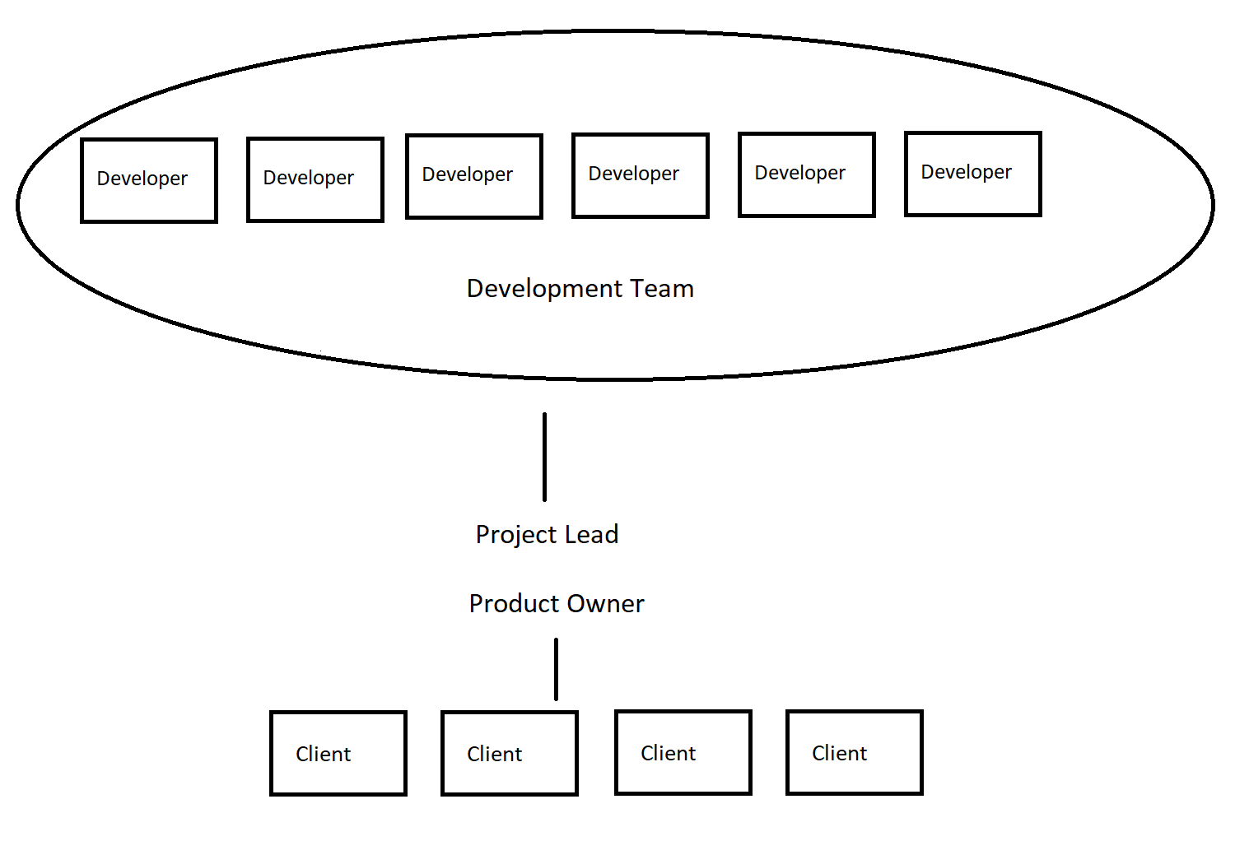

2.2 SCM Responsibilities

Users: Users will be interacting with the software. They will provide their own DB and use their own text queries. The software will the return the result of the natural language query.
Product owner: The product owner is responsible for ensuring that the product is to the clients satisfactions. The included responsibility is client communication, front end design, making sure the product doesn’t over reach its scope, and that deadlines are met.
Team lead: The team lead is directly responsible over the development teams work. The team lead oversees scrum meetings, sets milestones, and distributes tasks among his lessers.
Developers: The developers, are responsible for completion of their task, and do the actual coding work.

2.3 Relationship of CM to the software process life cycle

As the server technology becomes more and more popular, the life cycle of this software should be very long.

2.4 SCM Resources
For source control, github and git is used. To keep the developer team on track Jira is used, where the the team lead assigns tasks to each developer.

3. SCM ACTIVITIES

3.1 Configuration Identification
All configuration changes are to be approved in github by the team lead.

3.1.1 Specification Identification

Using windows, Linux and Mac system for developing th software, the software of making the code is Neo4j.

3.1.2 Change Control Form Identification

The software’s changing must be reviewed by all the team members first, mark each change and combine the changes to make a better software.

3.1.3 Project Baselines

Need to be done next.
a) Identification and documentation of the need for a change;
b) Analysis and evaluation of a change request;
c) Approval or disapproval of a request;
d) Verification, implementation, and release of a change.

3.1.4 Library
NLP is composed of end-user products, module products and data

3.2 Configuration Control

3.2.1 Procedures for changing baseline

Keep tracking the changes when the team begin to create the software.

3.2.2 Procedures for processing change requests and approvals
Change requests are posted as either issues on Jira, or pull requests on github. The Team Lead approves or denies changes.

3.2.3 Organizations assigned responsibilities for change control

The team lead maintains the master branch of the git, while each developers has a branch. The product owner requests new tasks to be done by development team.

3.2.4 Interfaces

This software will have to interface with a DB. This will be a Neo4j(cypher) graphical database which require it’s own interface software, provided by Neo4j
Software Interfaces: Using Neo4j(cypher) the

3.2.5 Level of control

Documents version will be controlled with git. Each developer has their own branch, where they can maintain documents and milestone progress.

3.2.6 Document revisions

Documents are assigned to each member of the development team. They are responsible for maintaining the latest version. No approval is needed, but documents are often revised by the product owner and project lead. They are to be updated bi-weekly

3.2.7 Automated tools used to perform change control

Neo4j, GIT, and JIRA will be used to perform version and change controls.

3.3 Configuration Status Accounting

Always track and report the process of software. Understand what are the questions and what need to be improved

3.3.1 Storage, handling and release of project media

All the data should be stored and saved in the database for users.

3.3.2 Information and Control

3.3.3 Reporting
The the PM should be available for getting a status report of changes in the software. Project Team should always schedule to do a report to the CCB about once a week.

3.3.4 Release process
There is no public product to be released, as this is still a research project. Eventually, implementation directly into the cypher library would be a conventional means of release.

3.3.5 Document Status Accounting
If any changes occur, the changes will be sent to our client. After review and approval, the changes will be made.

3.3.6 Change Management Status Accounting

The frequency of updating the informations should be in one or two weeks.

3.4 Configuration Audits and Reviews
All configurations changes made by a developer are verified by the product lead for any merge errors. The baseline is reviewed every sprint period. Consistency errors are to be fixed by the developer that pushed the change.

4. CM Milestones
Milestone are set both by the team lead and product owner. All milestones are expected to pass testing and be bug free. The software should be able to parse given NLP queries, and run them as cypher queries on out test database, given by our client.

5. Training
Because this software is intended to be easy to use, official training is kept to a minimum. Maintenance or intimate understanding of this program should be from the documentation provided.

6. Subcontractor/Vendor Support
This does not apply to this software. There is no support for vendor or subcontractor..

